University of Wolverhampton

# School of Mathematics and Computer Science

**5CS022 Distribute and Cloud Systems Programming Week 1 Workshop Overview**

The aim of this workshop is to familiarize you with building, compiling and running MPI programs. You can carry out this workshop either the university servers: thinlinc.wlv.ac.uk or your own Linux system (if you prefer to use Putty to log in instead of the Thinlinc client, connect to the server tl-01.wlv.ac.uk instead).

# Task 1:

1. Download the sample MPI programs from Canvas into your Linux system. Compile and run the program mpi01.c. To compile it, run the following command in the terminal:

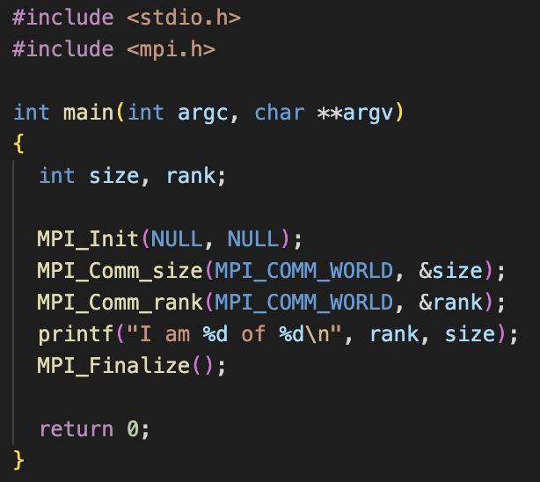

**Output**

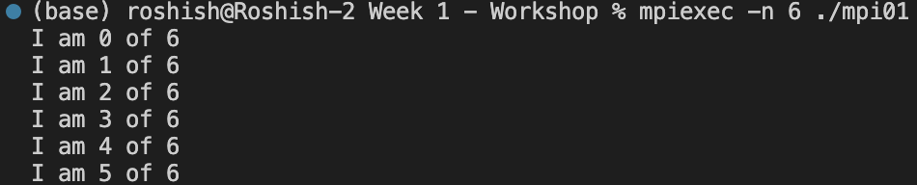

1. Compile and run the program mpi02.c. Try running it with 2, 3 and 4 processes. E.g.:

**Task 2:**

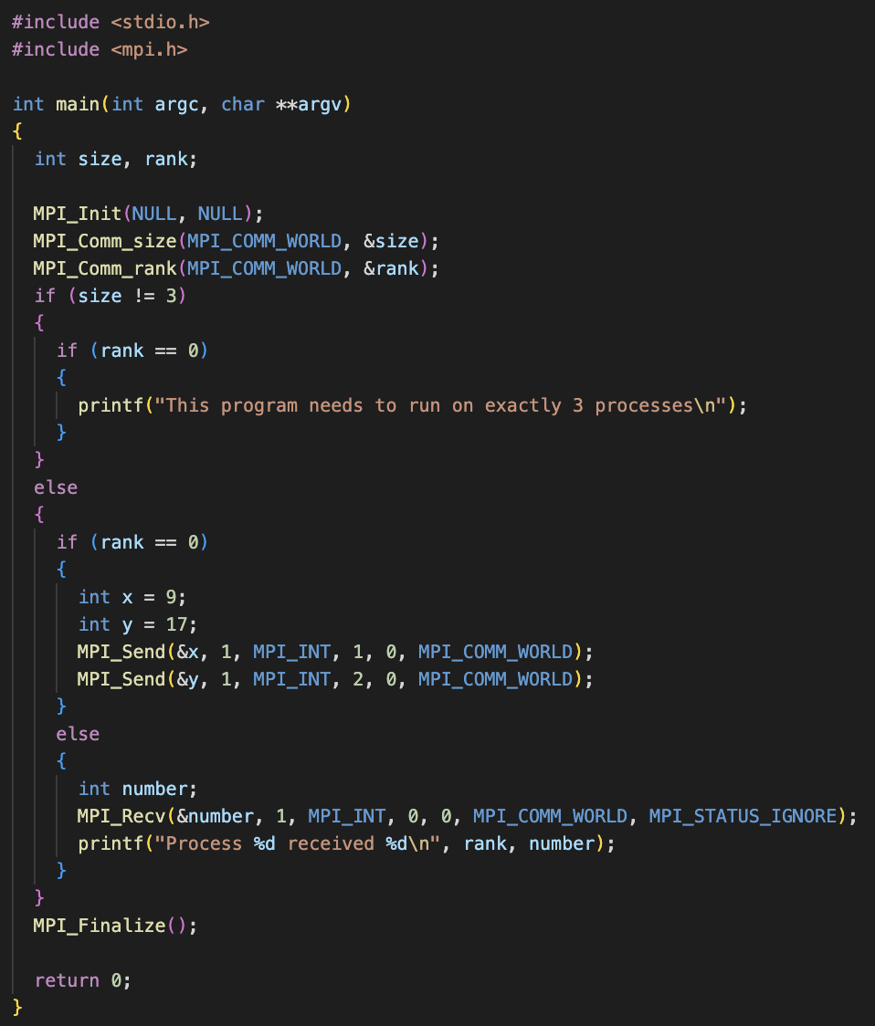

**Output**

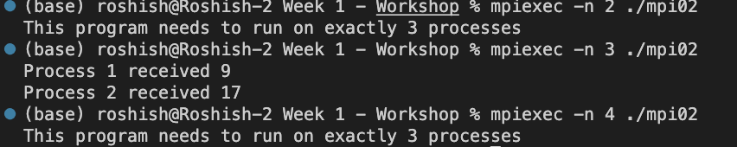

1. Now change the code so that you remove the check for only 3 processes. Now run it with 2, then 3 , then 4 and then more processes.

Task 3

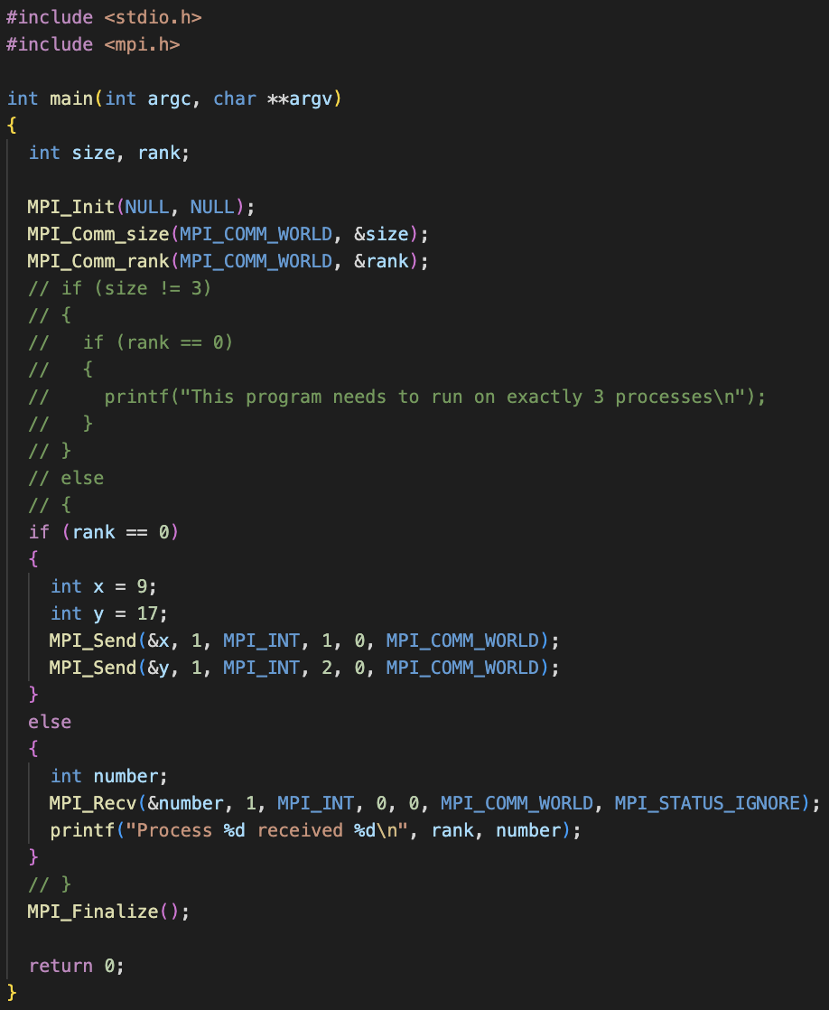

**Output**

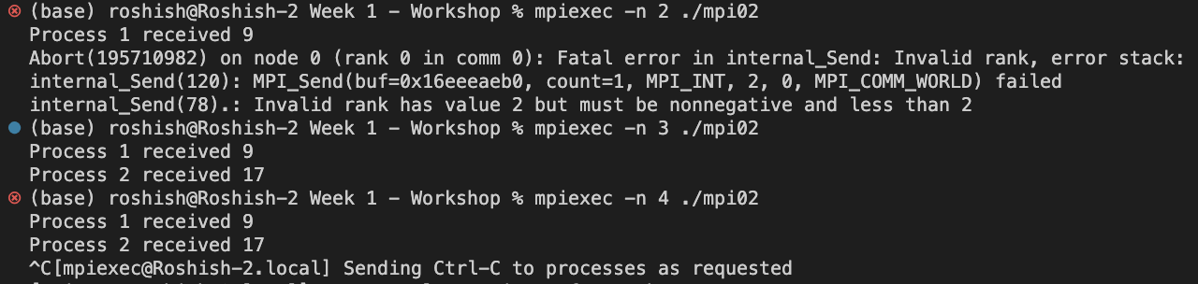

1. When you try to run it with 4 or more processes, it probably runs and appears to work, but never ends. You will have to end with "Ctrl-C". Why do you think it doesn't end when you run it with more than 3 processes? Change it so that it will work with any number of processes.

Task 4:

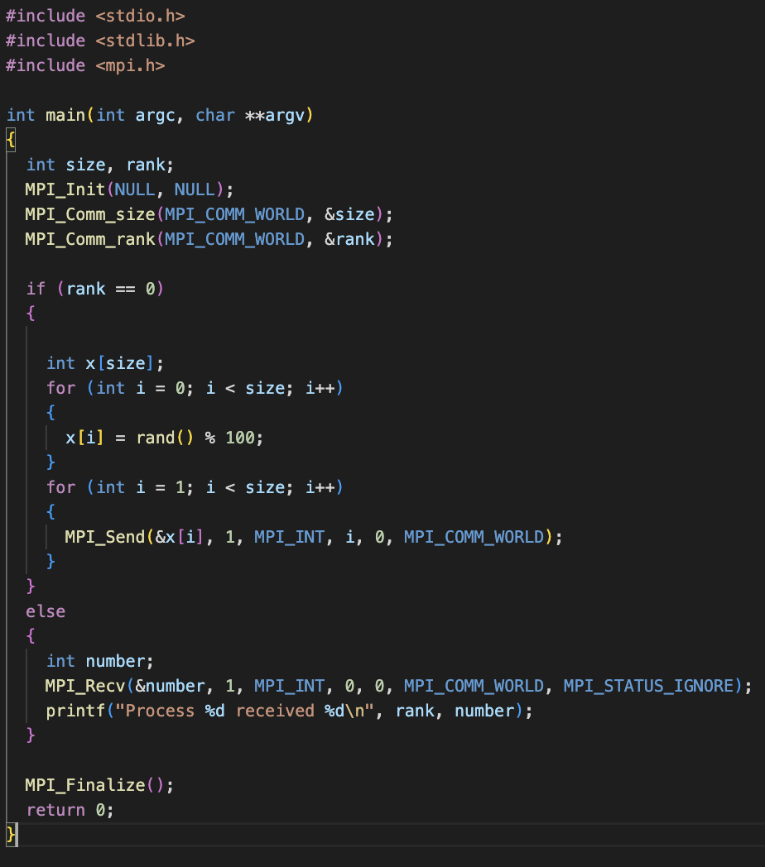

1. Build and run the program mpi03.c. In this program Process 0 will wait for messages from Process 1 and Process 2. However, Process 1 end sup blocking Process 2 because it sleeps for 5 seconds. How would you change the code so that Process 1 does not block Process 2, even if it does sleep for 5 seconds?

Task 5:

1. The following is a simple program that looks for prime numbers between 1 to 10000:

# #include <stdio.h>

**int main(int argc, char **argv)**

# {

**int i, c;**

# int nstart=1, nfinish=10000;

**printf("%s : Prime numbers between %d and %d are :\n", nstart, nfinish);**

# for(i=nstart; i<=nfinish; i++)

**{**

# for(c=2; c<=i-1; c++)

**{**

# if ( i%c==0 ) break;

**}**

# if ( c==i )

**printf("%s : %d\n",argv[0], i);**

# }

**return 0;**

# }

Convert it to MPI so that it can run with different numbers of processes including just one process.

Task 6 :

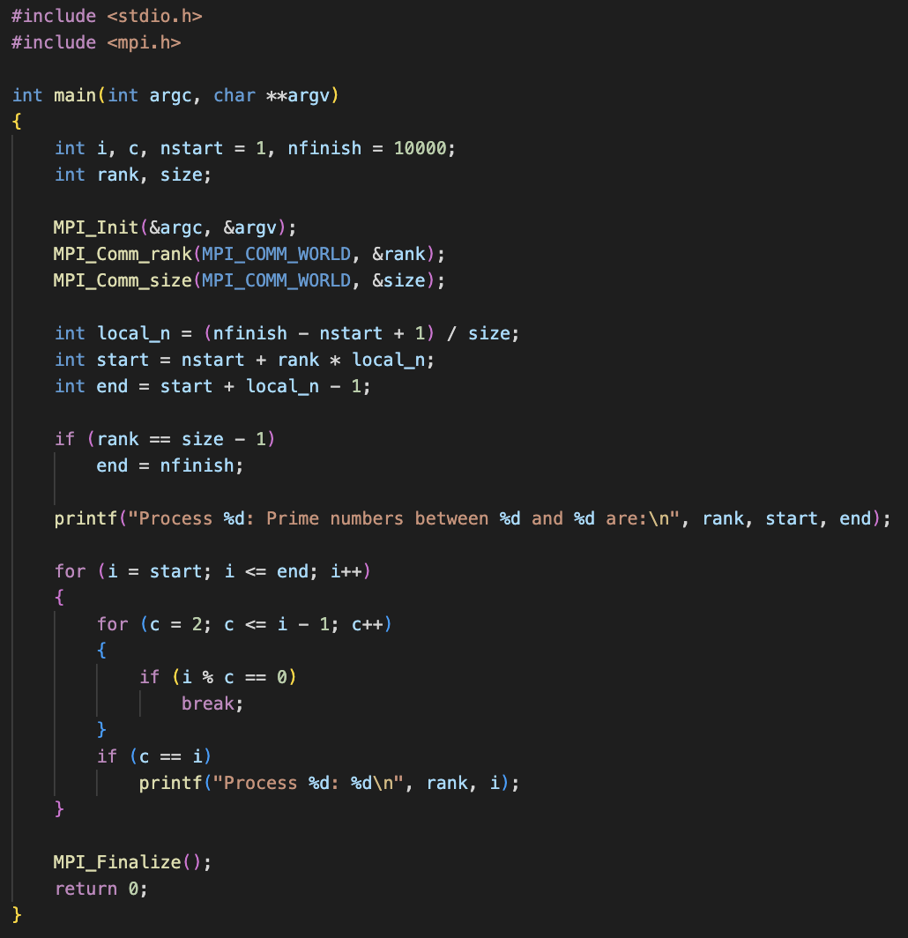

**Output**

